

PVKN GOVT COLLEGE (A) CHITTOOR
DEPARTMENT OF SANSKRIT
5 YEARS TIMETABLE 2019-24

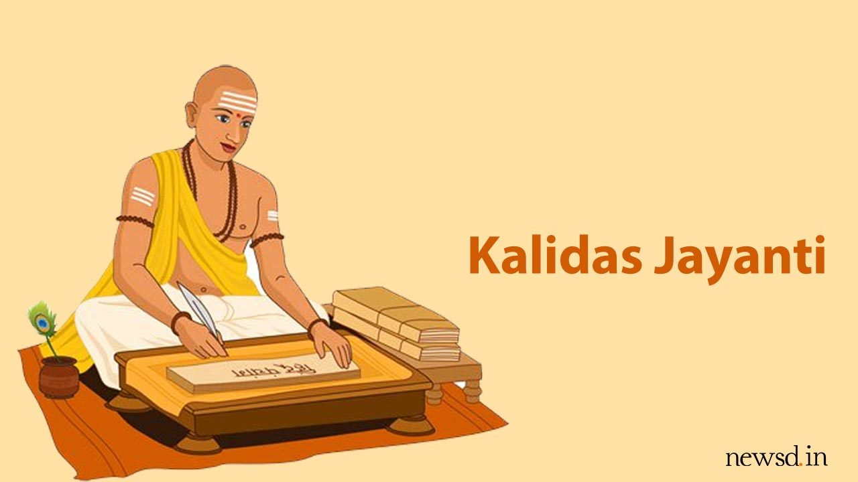

PVKN GOVT COLLEGE (A) CHITTOOR
TIME TABLE 2019-20
DEPARTMENT OF SANSKRIT

DAY | 1 | 2 | 3 | 4 | 5
MON | II  B.A | I. B.A | I. B.SC |  | II  B.SC
TUE | II B.A | I. B.A | I. B.COM |  | II  B.COM
WED | I. B.COM | II B.COM | I. B.SC | II B.SC
THU | I. B.A | I. B.COM | II B.COM | I. B.SC
FRI | II B.A | I. B.A | I. B.SC
SAT |  | I. B.COM |  | II B.SC

NAME OF THE LECTURER: A. REKHA

PVKN GOVT COLLEGE (A) CHITTOOR
TIME TABLE 2020-21
DEPARTMENT OF SANSKRIT

DAY | 1 | 2 | 3 | 4 | 5
MON | II  B.A | I. B.A | I. B.SC |  | II  B.SC
TUE | II B.A | I. B.A | I. B.COM |  | II  B.COM
WED | I. B.COM | II B.COM | I. B.SC | II B.SC
THU | I. B.A | I. B.COM | II B.COM | I. B.SC
FRI | II B.A | I. B.A | I. B.SC
SAT |  | I. B.COM |  | II B.SC

NAME OF THE LECTURER: A. REKHA

PVKN GOVT COLLEGE (A) CHITTOOR
TIME TABLE 2021-22
DEPARTMENT OF SANSKRIT

DAY | 1 | 2 | 3 | 4 | 5
MON | II  B.A | I. B.A | I. B.SC |  | II  B.SC
TUE | II B.A | I. B.A | I. B.COM |  | II  B.COM
WED | I. B.COM | II B.COM | I. B.SC | II B.SC
THU | I. B.A | I. B.COM | II B.COM | I. B.SC
FRI | II B.A | I. B.A | I. B.SC
SAT |  | I. B.COM |  | II B.SC

NAME OF THE LECTURER: A. REKHA

PVKN GOVT COLLEGE (A) CHITTOOR
TIME TABLE 2022-23
DEPARTMENT OF SANSKRIT

DAY | 1 | 2 | 3 | 4 | 5
MON | II  B.A |  | I. B.A &I. B.SC |  | I. B.A &I. B.SC
TUE | II B.A |  | I. B.COM |  | II  B.COM
WED | I. B.COM | II B.COM | I. B.SC | I. B.A &I. B.SC
THU |  | I. B.COM | II B.COM | I. B.A &I. B.SC
FRI | II B.A | I. B.A | I. B.A &I. B.SC
SAT |  | I. B.COM |  | II B.SC

NAME OF THE LECTURER: A. REKHA

PVKN GOVT COLLEGE (A) CHITTOOR
TIME TABLE 2023-24
ALL SECOND LANGUAGES TELUGU, SANSKRIT, HINDI, TAMIL

DAY | 1 | 2 | 3 | 4 | 5
MON | IISEEK&SEL  B.A | I. B.A | I. B.SC |  | IISEEK&SEL  B.SC
TUE | IISEEK&SEL  B.A | I. B.A | I. B.COM |  | IISEEK&SEL  B.COM
WED | I. B.COM | IISEEK&SEL  B.COM | I. B.SC | IISEEK&SEL  B.SC
THU | I. B.A | I. B.COM | IISEEK&SEL  B.COM | I. B.SC
FRI | IISEEK&SEL  B.A | I. B.A | I. B.SC
SAT |  | I. B.COM |  | IISEEK&SEL  B.SC

NAME OF THE LECTURER: A. REKHA

